To: Specification No.:

Delivery Specification
Product Name: TPU Paint Protection Film
Model No.:
Date of Establishment:
Manufacturer | Buyer
泰浪商务

1. Scope of Application
This specification applies to the TPU paint protection film produced by 泰浪商务

product name：
model No.:
Buyer：

2. Purpose
This specification is formulated to ensure the delivery quality of the TPU paint protection film
Product name：
Model No.:

3. Product Form

(1) Structure
The product adopts a 5-layer structure:
2.0mil Toray high-definition protective film on the surface,
0.28mil Kaxiu repair coating,
particle TPU substrate ( mil),
1.2mil Bostik Aroset pressure-sensitive adhesive layer, and 3mil release film.
2.0mil Toray high-definition protective film
0.28mil Japanese-style repair coating
Aliphatic polycaprolactone TPU substrate
1.2mil Bostik Ashland pressure-sensitive adhesive layer
3mil matte release film

(2) Shape
The product is in film form, cut to a length of 15m and a width of 1524mm, wound into a roll on a 3-inch (1 inch = 25.4mm) plastic tube with the release film layer as the inner surface.

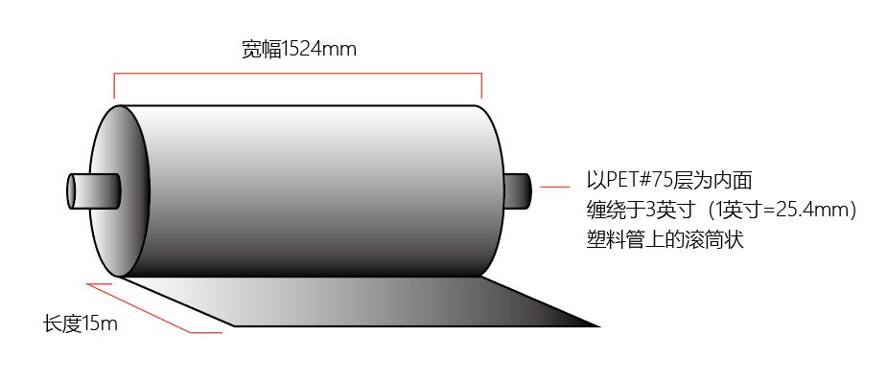

(3) Splicing
No splicing.

4. Packaging and Marking

(1) Packaging Form
① A 3-inch plastic tube is used as the core, and the product is packaged in a suspended manner.
② The inner packaging is fully wrapped with polyethylene film.
③ The outer packaging is bundled with corrugated paper.

(2) Label
① Product labels are affixed to the inner side of the product roll core and the side of the outer corrugated carton.
② The product label contains the following information:
Model No.:
Size: 1.524m*15m
Traceability No.: Refer to the description in "(3)" below

(3) Definition and Explanation of Batch Number
① One batch is defined as one continuous production of the same product type.
② The batch number consists of the following numbers and English letters.
(Example) S1A1001CF1001
S1A1001 CF1 001
Production Order No：
Finished Product Serial Numbers

Rewinding Team

5. Product Quality Specifications
The TPU paint protection film (product name, model No.: ) meets the following specifications for each item:
Test Item |  | Test Method | Unit | Specification Standard Value
Thickness | Total Thickness | GB/T 6672 | μm
Thickness | Usable Layer Thickness |  | μm
Width |  | GB/T 6673 | mm | 1522±2
Product Elongation at Break |  | ASTM D-882 | % | ≥300
Tensile Strength |  | ASTM D-882 | MPa | ≥16
Elastic Modulus |  | ASTM D-882 | Kgf/cm² | 180≤E≤350
UV Barrier Rate |  | GB/T 2680 | % | ≥90
Haze |  | ASTM D1003 | ≤ | 2.0
Adhesive Force | Initial Adhesion | Test 20 minutes after pasting on steel plate | N/in | 15≤F≤25
Adhesive Force | Permanent Adhesion | Test 168 hours after pasting on steel plate |  | 20≤F≤30
Elongation at Break of Repair Layer |  | ASTM D-882 | % | ≥180
Acid and Alkali Resistance |  | Immerse in HCl solution (pH 2~3) and NaOH solution (pH 13~14) for 30 minutes respectively | / | No abnormality
Special Requirement Test Method |  | Film pasting test is normal

6. Submitted Materials
Factory quality inspection report: Test shall be carried out according to the manufacturing batch, and the factory quality inspection report shall be provided in the format of Annex I.

7. Validity Period
This delivery specification is valid for 1 year from the date of establishment. After the expiration of the period, both parties shall confirm whether modification or update is required.

Annex I: 泰浪商务 Paint Protection Film Finished Product Inspection Report
Product Code |  |  |  |  | Production LOT
Production Order No |  |  |  |  | Manufacturing Date
Test Item |  |  | Test Method | Unit | Standard Value | Test Result | Judge
Appearance |  |  | Visual inspection | / | Meet product appearance quality requirements
Thickness | Total Thickness |  | GB/T 6672 | μm | 328±10
Thickness | Usable Layer Thickness |  |  | μm | 186±10
Width |  |  | GB/T 6673 | mm | 1522±2
Product Elongation at Break |  |  | ASTM D-882 | % | ≥300
Tensile Strength |  |  | GB/T 17657-2013 | MPa | ≥16
Elastic Modulus |  |  | ASTM D-882 | Kgf/cm² | 180≤E≤350
UV Barrier Rate |  |  | GB/T 2680 | % | ≥90
Haze |  |  | ASTM D1003 | % | ≤2.0
Adhesive Force |  | Initial Adhesion | Test 20 minutes after pasting on steel plate | N/in | 15≤F≤25
Adhesive Force |  | Permanent Adhesion | Test 168 hours after pasting on steel plate |  | 20≤F≤30
Elongation at Break of Repair Layer |  |  | ASTM D-882 | % | ≥100
Repairability |  |  | Scratch 30 times with fine copper brush under 200g/cm² load, repair with 70℃ hot water or hot air | S | ≤5
Scratch Resistance |  |  |  | / | No scratch
Acid and Alkali Resistance |  |  | Immerse in HCl solution (pH 2~3) and NaOH solution (pH 13~14) for 30 minutes respectively | / | No abnormality
Special Requirement Test Method
Comprehensive Judgment |  |  |  |  | Inspection Date
Inspector |  |  |  |  | Reviewer
Remarks |  |  |  |  | </

